모바일프로그래밍 과제11 컴퓨터소프트웨어공학과 2-YA 20202296 전채린

실습 10-1 새로운 액티비티 추가하기

[소스코드]

activity_main.xml

<?xml version="1.0" encoding="utf-8"?>  
<LinearLayout xmlns:android="http://schemas.android.com/apk/res/android"  
 xmlns:app="http://schemas.android.com/apk/res-auto"  
 xmlns:tools="http://schemas.android.com/tools"  
 android:layout_width="match_parent"  
 android:layout_height="match_parent"  
 android:orientation="vertical"  
 tools:context=".MainActivity">  
 /* 02 액티비티의 개요  
 실습10-1 새로운 액티비티 추가하기 */  
 /* 메인 화면의 버튼을 클릭하면 서브 화면이 나오는 응용프로그램 */  
 /* 예제10-1 activity_main.xml */  
  
 <TextView  
 android:layout_width="match_parent"  
 android:layout_height="wrap_content"  
 android:text="20202296 전채린" />  
 <TextView  
 android:layout_width="match_parent"  
 android:layout_height="wrap_content"  
 android:text="첫 번째 화면" />  
 <Button  
 android:layout_width="match_parent"  
 android:layout_height="wrap_content"  
 android:id="@+id/btnNewActivity"  
 android:text="새 화면 열기" />  
</LinearLayout>

second.xml

<?xml version="1.0" encoding="utf-8"?>  
<LinearLayout xmlns:android="http://schemas.android.com/apk/res/android"  
 android:orientation="vertical" android:layout_width="match_parent"  
 android:background="#00FF00"  
 android:layout_height="match_parent">  
  
 /* 02 액티비티의 개요  
 실습10-1 새로운 액티비티 추가하기 */  
 /* 메인 화면의 버튼을 클릭하면 서브 화면이 나오는 응용프로그램 */  
 /* 예제10-2 second.xml */  
  
 <TextView  
 android:layout_width="match_parent"  
 android:layout_height="wrap_content"  
 android:text="20202296 전채린" />  
 <TextView  
 android:layout_width="match_parent"  
 android:layout_height="wrap_content"  
 android:text="두 번째 화면" />  
 <Button  
 android:layout_width="match_parent"  
 android:layout_height="wrap_content"  
 android:id="@+id/btnReturn"  
 android:text="돌아가기" />  
</LinearLayout>

MainActivity.kt

package aca.hankook.project10_1  
  
import android.content.Intent  
import androidx.appcompat.app.AppCompatActivity  
import android.os.Bundle  
import kotlinx.android.synthetic.main.activity_main.*  
  
class MainActivity : AppCompatActivity() {  
  
 override fun onCreate(savedInstanceState: Bundle?) {  
 super.onCreate(savedInstanceState)  
 setContentView(R.layout.*activity_main*)  
  
 /* 예제10-5 MainActivity.kt 코드 */  
 btnNewActivity.setOnClickListener **{** var intent = Intent(*applicationContext*, SecondActivity::class.*java*)  
 this.startActivity(intent)  
 **}** }  
}

Second2Activity.kt

package aca.hankook.project10_1  
  
import androidx.appcompat.app.AppCompatActivity  
import android.os.Bundle  
import kotlinx.android.synthetic.main.second2.*  
  
class Second2Activity : AppCompatActivity() {  
  
 override fun onCreate(savedInstanceState: Bundle?) {  
 super.onCreate(savedInstanceState)  
 setContentView(R.layout.*second2*)  
  
 /* 예제10-4 Second2Activity.kt 코드 */  
 btnReturn2.setOnClickListener **{** this.finish()  
 **}** }  
}

AndroidManifest.xml

<?xml version="1.0" encoding="utf-8"?>  
<manifest xmlns:android="http://schemas.android.com/apk/res/android"  
 package="aca.hankook.project10_1">  
  
 <application  
 android:allowBackup="true"  
 android:icon="@mipmap/ic_launcher"  
 android:label="@string/app_name"  
 android:roundIcon="@mipmap/ic_launcher_round"  
 android:supportsRtl="true"  
 android:theme="@style/AppTheme">  
 <activity android:name=".Second2Activity"></activity>  
 <activity android:name=".MainActivity">  
 <intent-filter>  
 <action android:name="android.intent.action.MAIN" />  
  
 <category android:name="android.intent.category.LAUNCHER" />  
 </intent-filter>  
 </activity>  
 /* 예제10-6 AndroidManifest.xml 수정 */  
 <activity  
 android:name=".SecondActivity"  
 android:label="Second 액티비티" />  
 </application>  
</manifest>

<activity  
 android:name=".SecondActivity"  
 android:label="Second 액티비티" />  
 </application>  
</manifest>

[실행결과]

1) 첫 번째 화면

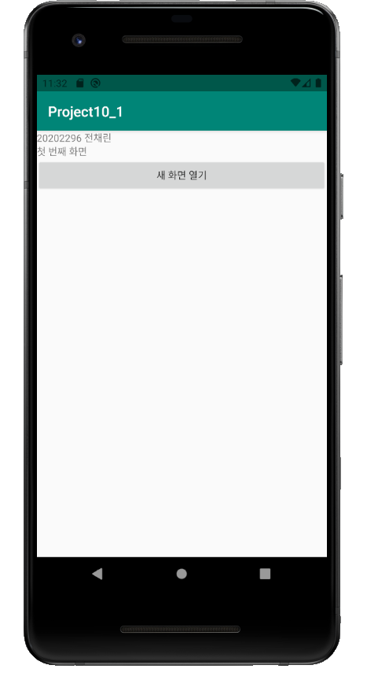

2) 두 번째 화면

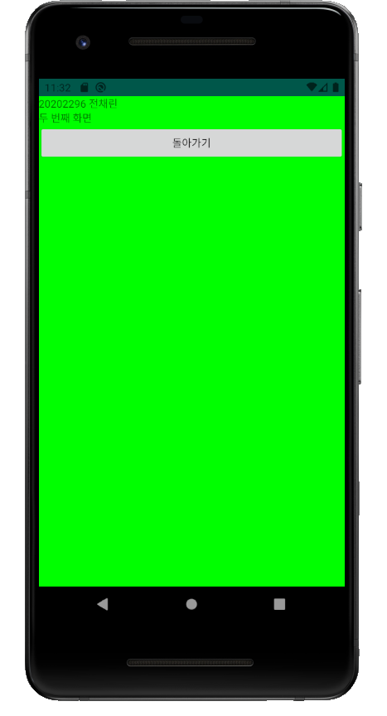

직접풀어보기 10-1 새로운 액티비티 추가하기

[소스코드]

activity_main.xml

<?xml version="1.0" encoding="utf-8"?>  
<LinearLayout xmlns:android="http://schemas.android.com/apk/res/android"  
 xmlns:app="http://schemas.android.com/apk/res-auto"  
 xmlns:tools="http://schemas.android.com/tools"  
 android:layout_width="match_parent"  
 android:layout_height="match_parent"  
 android:orientation="vertical"  
 tools:context=".MainActivity">  
 /* 02 액티비티의 개요  
 직접풀어보기 10-1 새로운 액티비티 추가하기 */  
 /* [실습10-1]을 다음과 같이 수정하라.  
 ThirdActivity를 추가한다.  
 라디오버튼으로 선택된 액티비티가 나오게 한다.  
 */  
 /* 직접풀어보기10-1 activity_main.xml */  
  
 <TextView  
 android:layout_width="match_parent"  
 android:layout_height="wrap_content"  
 android:text="20202296 전채린" />  
 <TextView  
 android:layout_width="match_parent"  
 android:layout_height="wrap_content"  
 android:text="첫 번째 화면" />  
 <RadioGroup  
 android:layout_width="match_parent"  
 android:layout_height="wrap_content">  
 <RadioButton  
 android:layout_width="match_parent"  
 android:layout_height="wrap_content"  
 android:id="@+id/rdo2"  
 android:text="Second 액티비티" />  
 <RadioButton  
 android:layout_width="match_parent"  
 android:layout_height="wrap_content"  
 android:id="@+id/rdo3"  
 android:text="Third 액티비티" />  
 </RadioGroup>  
 <Button  
 android:layout_width="match_parent"  
 android:layout_height="wrap_content"  
 android:id="@+id/btnNewActivity"  
 android:text="새 화면 열기" />  
</LinearLayout>

second.xml

<?xml version="1.0" encoding="utf-8"?>  
 <LinearLayout xmlns:android="http://schemas.android.com/apk/res/android"  
 xmlns:app="http://schemas.android.com/apk/res-auto"  
 xmlns:tools="http://schemas.android.com/tools"  
 android:layout_width="match_parent"  
 android:layout_height="match_parent"  
 android:background="#F7F0AE"  
 android:orientation="vertical"  
 tools:context=".SecondActivity">  
  
 /* 02 액티비티의 개요  
 직접풀어보기10-1 새로운 액티비티 추가하기 */  
 /* 직접풀어보기10-2 second.xml */  
  
 <TextView  
 android:layout_width="match_parent"  
 android:layout_height="wrap_content"  
 android:text="20202296 전채린" />  
 <TextView  
 android:layout_width="match_parent"  
 android:layout_height="wrap_content"  
 android:text="두 번째 화면" />  
 <Button  
 android:layout_width="match_parent"  
 android:layout_height="wrap_content"  
 android:id="@+id/btnReturn1"  
 android:text="돌아가기" />  
</LinearLayout>

third.xml

<?xml version="1.0" encoding="utf-8"?>  
 <LinearLayout xmlns:android="http://schemas.android.com/apk/res/android"  
 xmlns:app="http://schemas.android.com/apk/res-auto"  
 xmlns:tools="http://schemas.android.com/tools"  
 android:layout_width="match_parent"  
 android:layout_height="match_parent"  
 android:orientation="vertical"  
 android:background="#0000FF"  
 tools:context=".ThirdActivity">  
  
 <TextView  
 android:layout_width="match_parent"  
 android:layout_height="wrap_content"  
 android:text="20202296 전채린" />  
 <TextView  
 android:layout_width="match_parent"  
 android:layout_height="wrap_content"  
 android:text="세 번째 화면" />  
 <Button  
 android:layout_width="match_parent"  
 android:layout_height="wrap_content"  
 android:id="@+id/btnReturn2"  
 android:text="돌아가기" />  
</LinearLayout>

MainActivity.kt

package aca.hankook.practice10_1  
  
import android.content.Intent  
import androidx.appcompat.app.AppCompatActivity  
import android.os.Bundle  
import kotlinx.android.synthetic.main.activity_main.*  
  
class MainActivity : AppCompatActivity() {  
  
 override fun onCreate(savedInstanceState: Bundle?) {  
 super.onCreate(savedInstanceState)  
 setContentView(R.layout.*activity_main*)  
  
 /* 직접풀어보기 10-5 MainActivity.kt 코드 */  
 btnNewActivity.setOnClickListener **{** var intent1 :Intent  
 if(rdo2.*isChecked*) {  
 intent1 = Intent(*applicationContext*, SecondActivity::class.*java*)  
 } else {  
 intent1 = Intent(*applicationContext*, ThirdActivity::class.*java*)  
 }  
 this.startActivity(intent1)  
 **}** }  
}

SecondActivity.kt

package aca.hankook.practice10_1  
  
import androidx.appcompat.app.AppCompatActivity  
import android.os.Bundle  
import kotlinx.android.synthetic.main.second.*  
import kotlinx.android.synthetic.main.third.*  
  
class SecondActivity : AppCompatActivity() {  
  
 override fun onCreate(savedInstanceState: Bundle?) {  
 super.onCreate(savedInstanceState)  
 setContentView(R.layout.*second*)  
  
 btnReturn1.setOnClickListener **{** this.finish()  
 **}** }  
}

ThirdActivity.kt

package aca.hankook.practice10_1  
  
import androidx.appcompat.app.AppCompatActivity  
import android.os.Bundle  
import kotlinx.android.synthetic.main.third.*  
  
class ThirdActivity : AppCompatActivity() {  
  
 override fun onCreate(savedInstanceState: Bundle?) {  
 super.onCreate(savedInstanceState)  
 setContentView(R.layout.*third*)  
  
 btnReturn2.setOnClickListener **{** this.finish()  
 **}** }  
}

AndroidManifest.xml

<?xml version="1.0" encoding="utf-8"?>  
<manifest xmlns:android="http://schemas.android.com/apk/res/android"  
 package="aca.hankook.project10_1">  
  
 <application  
 android:allowBackup="true"  
 android:icon="@mipmap/ic_launcher"  
 android:label="@string/app_name"  
 android:roundIcon="@mipmap/ic_launcher_round"  
 android:supportsRtl="true"  
 android:theme="@style/AppTheme">  
 <activity android:name=".Second2Activity"></activity>  
 <activity android:name=".MainActivity">  
 <intent-filter>  
 <action android:name="android.intent.action.MAIN" />  
  
 <category android:name="android.intent.category.LAUNCHER" />  
 </intent-filter>  
 </activity>  
 /* 예제10-6 AndroidManifest.xml 수정 */  
 <activity  
 android:name=".SecondActivity"  
 android:label="Second 액티비티" />  
 </application>  
</manifest>

<activity  
 android:name=".SecondActivity"  
 android:label="Second 액티비티" />  
 </application>  
</manifest>

[실행결과]

1) 첫 번째 화면

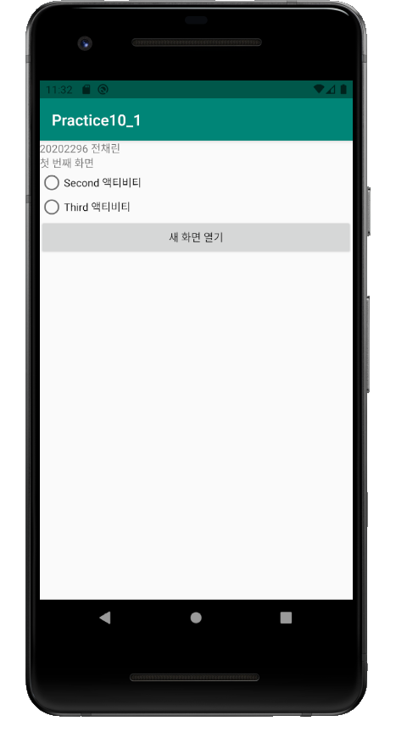

2) 두 번째 화면

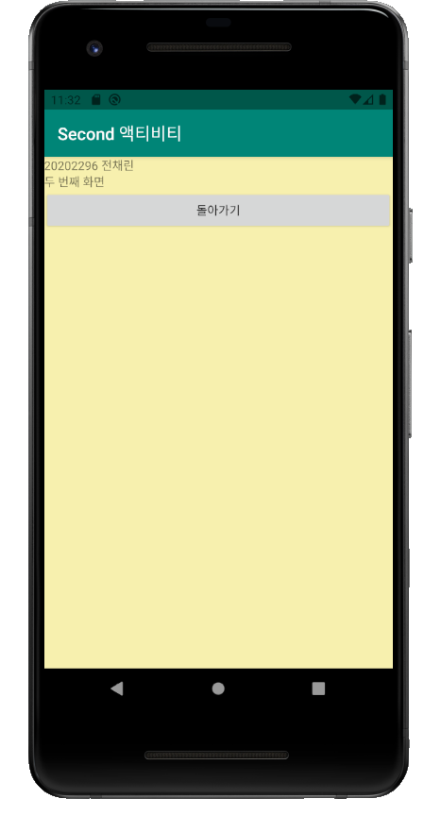

3) 세 번째 화면

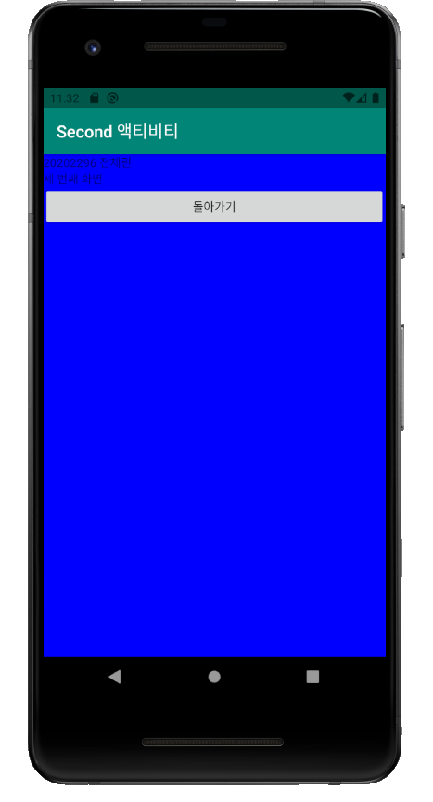

실습 10-2 명화 선호도 투표 앱 만들기

[소스코드]

activity_main.xml

<?xml version="1.0" encoding="utf-8"?>  
<LinearLayout xmlns:android="http://schemas.android.com/apk/res/android"  
 xmlns:app="http://schemas.android.com/apk/res-auto"  
 xmlns:tools="http://schemas.android.com/tools"  
 android:layout_width="match_parent"  
 android:layout_height="match_parent"  
 android:orientation="vertical"  
 tools:context=".MainActivity">  
  
 /* 03 명시적 인텐트  
 실습10-2 명화 선호도 투표 앱 만들기 */  
 /* 유명한 화가인 르누아르의 그림에 대한 선호도를 투표하고 결과를 레이팅바로 보여주는 앱 만들기  
 메인 액티비티에서 좋아하는 그림에 투표한 후 '투표 종료'를 클릭하면 결과가 나옴 */  
 /* 예제10-9 activity_main.xml */  
 <TextView  
 android:layout_width="match_parent"  
 android:layout_height="wrap_content"  
 android:text="20202296 전채린" />  
 <LinearLayout  
 android:layout_width="match_parent"  
 android:layout_height="0dp"  
 android:layout_weight="3" >  
 <ImageView  
 android:layout_width="wrap_content"  
 android:layout_height="wrap_content"  
 android:id="@+id/iv1"  
 android:layout_margin="5dp"  
 android:layout_weight="1"  
 android:src="@drawable/pic1" />  
 <ImageView  
 android:layout_width="wrap_content"  
 android:layout_height="wrap_content"  
 android:id="@+id/iv2"  
 android:layout_margin="5dp"  
 android:layout_weight="1"  
 android:src="@drawable/pic2" />  
 <ImageView  
 android:layout_width="wrap_content"  
 android:layout_height="wrap_content"  
 android:id="@+id/iv3"  
 android:layout_margin="5dp"  
 android:layout_weight="1"  
 android:src="@drawable/pic3" />  
 </LinearLayout>  
 <LinearLayout  
 android:layout_width="match_parent"  
 android:layout_height="0dp"  
 android:layout_weight="3" >  
 <ImageView  
 android:layout_width="wrap_content"  
 android:layout_height="wrap_content"  
 android:id="@+id/iv4"  
 android:layout_margin="5dp"  
 android:layout_weight="1"  
 android:src="@drawable/pic4" />  
 <ImageView  
 android:layout_width="wrap_content"  
 android:layout_height="wrap_content"  
 android:id="@+id/iv5"  
 android:layout_margin="5dp"  
 android:layout_weight="1"  
 android:src="@drawable/pic5" />  
 <ImageView  
 android:layout_width="wrap_content"  
 android:layout_height="wrap_content"  
 android:id="@+id/iv6"  
 android:layout_margin="5dp"  
 android:layout_weight="1"  
 android:src="@drawable/pic6" />  
 </LinearLayout>  
 <LinearLayout  
 android:layout_width="match_parent"  
 android:layout_height="0dp"  
 android:layout_weight="3" >  
 <ImageView  
 android:layout_width="wrap_content"  
 android:layout_height="wrap_content"  
 android:id="@+id/iv7"  
 android:layout_margin="5dp"  
 android:layout_weight="1"  
 android:src="@drawable/pic7" />  
 <ImageView  
 android:layout_width="wrap_content"  
 android:layout_height="wrap_content"  
 android:id="@+id/iv8"  
 android:layout_margin="5dp"  
 android:layout_weight="1"  
 android:src="@drawable/pic8" />  
 <ImageView  
 android:layout_width="wrap_content"  
 android:layout_height="wrap_content"  
 android:id="@+id/iv9"  
 android:layout_margin="5dp"  
 android:layout_weight="1"  
 android:src="@drawable/pic9" />  
 </LinearLayout>  
 <Button  
 android:layout_width="match_parent"  
 android:layout_height="0dp"  
 android:id="@+id/btn1"  
 android:layout_weight="1"  
 android:text="투표 종료" />  
</LinearLayout>

result.xml

<?xml version="1.0" encoding="utf-8"?>  
<TableLayout xmlns:android="http://schemas.android.com/apk/res/android"  
 xmlns:app="http://schemas.android.com/apk/res-auto"  
 xmlns:tools="http://schemas.android.com/tools"  
 android:layout_width="match_parent"  
 android:layout_height="match_parent"  
 android:gravity="center_vertical"  
 android:stretchColumns="0"  
 tools:context=".ResultActivity">  
  
 /* 예제10-10 result.xml */  
 <TableRow>  
 <TextView  
 android:id="@+id/tv1"  
 android:layout_gravity="center_vertical"  
 android:text="그림1"  
 android:textSize="15dp" />  
 <RatingBar  
 android:id="@+id/rbar1"  
 style="?android:attr/ratingBarStyleIndicator"  
 android:layout_gravity="right" />  
 </TableRow>  
 <TableRow>  
 <TextView  
 android:id="@+id/tv2"  
 android:layout_gravity="center_vertical"  
 android:text="그림2"  
 android:textSize="15dp" />  
 <RatingBar  
 android:id="@+id/rbar2"  
 style="?android:attr/ratingBarStyleIndicator"  
 android:layout_gravity="right" />  
 </TableRow>  
 <TableRow>  
 <TextView  
 android:id="@+id/tv3"  
 android:layout_gravity="center_vertical"  
 android:text="그림3"  
 android:textSize="15dp" />  
 <RatingBar  
 android:id="@+id/rbar3"  
 style="?android:attr/ratingBarStyleIndicator"  
 android:layout_gravity="right" />  
 </TableRow>  
 <TableRow>  
 <TextView  
 android:id="@+id/tv4"  
 android:layout_gravity="center_vertical"  
 android:text="그림4"  
 android:textSize="15dp" />  
 <RatingBar  
 android:id="@+id/rbar4"  
 style="?android:attr/ratingBarStyleIndicator"  
 android:layout_gravity="right" />  
 </TableRow>  
 <TableRow>  
 <TextView  
 android:id="@+id/tv5"  
 android:layout_gravity="center_vertical"  
 android:text="그림5"  
 android:textSize="15dp" />  
 <RatingBar  
 android:id="@+id/rbar5"  
 style="?android:attr/ratingBarStyleIndicator"  
 android:layout_gravity="right" />  
 </TableRow>  
 <TableRow>  
 <TextView  
 android:id="@+id/tv6"  
 android:layout_gravity="center_vertical"  
 android:text="그림6"  
 android:textSize="15dp" />  
 <RatingBar  
 android:id="@+id/rbar6"  
 style="?android:attr/ratingBarStyleIndicator"  
 android:layout_gravity="right" />  
 </TableRow>  
 <TableRow>  
 <TextView  
 android:id="@+id/tv7"  
 android:layout_gravity="center_vertical"  
 android:text="그림7"  
 android:textSize="15dp" />  
 <RatingBar  
 android:id="@+id/rbar7"  
 style="?android:attr/ratingBarStyleIndicator"  
 android:layout_gravity="right" />  
 </TableRow>  
 <TableRow>  
 <TextView  
 android:id="@+id/tv8"  
 android:layout_gravity="center_vertical"  
 android:text="그림8"  
 android:textSize="15dp" />  
 <RatingBar  
 android:id="@+id/rbar8"  
 style="?android:attr/ratingBarStyleIndicator"  
 android:layout_gravity="right" />  
 </TableRow>  
 <TableRow>  
 <TextView  
 android:id="@+id/tv9"  
 android:layout_gravity="center_vertical"  
 android:text="그림9"  
 android:textSize="15dp" />  
 <RatingBar  
 android:id="@+id/rbar9"  
 style="?android:attr/ratingBarStyleIndicator"  
 android:layout_gravity="right" />  
 </TableRow>  
 <TableRow>  
 <Button  
 android:id="@+id/btnReturn"  
 android:layout_span="2"  
 android:text="돌아가기" />  
 </TableRow>  
</TableLayout>

MainActivity.kt

package aca.hankook.project10_2  
  
import android.content.Intent  
import androidx.appcompat.app.AppCompatActivity  
import android.os.Bundle  
import android.widget.Toast  
import kotlinx.android.synthetic.main.activity_main.*  
  
class MainActivity : AppCompatActivity() {  
  
 override fun onCreate(savedInstanceState: Bundle?) {  
 super.onCreate(savedInstanceState)  
 setContentView(R.layout.*activity_main*)  
  
 /* 예제10-11 MainActivity.kt 코드 1 */  
 *title* = "명화 선호도 투표"  
  
 var voteCount = IntArray(9)  
 for(i in 0..8)  
 voteCount[i] = 0  
  
 var imageId = *arrayOf*(iv1, iv2, iv3, iv4, iv5, iv6, iv7, iv8, iv9)  
 var imageName = *arrayOf*("독서하는 소녀", "꽃장식 모자 소녀", "부채를 든 소녀",  
 "이레느깡 단 베르양", "잠자는 소녀", "테라스의 두 자매", "피아노 레슨", "피아노 앞의 소녀들", "해변에서")  
  
 /* 예제10-12 MainActivity.kt 코드 2 */  
 for(i in imageId.*indices*) {  
 imageId[i]!!.setOnClickListener **{** voteCount[i]++  
 Toast.makeText(*applicationContext*, imageName[i] + " 총 " + voteCount[i] + "표", Toast.*LENGTH_LONG*).show()  
 **}** }  
  
 /* 예제10-13 MainActivity.kt 코드 3 */  
 btn1.setOnClickListener **{** var intent1 = Intent(*applicationContext*, ResultActivity::class.*java*)  
 // data 보내기  
 intent1.putExtra("VoteCount", voteCount)  
 intent1.putExtra("ImageName", imageName)  
 this.startActivity(intent1)  
 **}** }  
}

ResultActivity.kt

package aca.hankook.project10_2  
  
import androidx.appcompat.app.AppCompatActivity  
import android.os.Bundle  
import kotlinx.android.synthetic.main.result.*  
  
class ResultActivity : AppCompatActivity() {  
  
 override fun onCreate(savedInstanceState: Bundle?) {  
 super.onCreate(savedInstanceState)  
 setContentView(R.layout.*result*)  
  
 /* 예제10-14 ResultActivity.kt 코드 1 */  
 *title* = "투표 결과"  
  
 var intent1 = this.getIntent()  
 var voteResult = intent1.getIntArrayExtra("VoteCount")  
 var imageName = intent1.getStringArrayExtra("ImageName")  
  
 /* 예제10-15 ResultActivity.kt 코드 2 */  
 var tv = *arrayOf*(tv1, tv2, tv3, tv4, tv5, tv6, tv7, tv8, tv9)  
 var rbar = *arrayOf*(rbar1, rbar2, rbar3, rbar4, rbar5, rbar6, rbar7, rbar8, rbar9)  
  
 for(i in voteResult!!.*indices*) {  
 tv[i].setText(imageName!![i])  
 rbar[i].*rating* = voteResult[i].toFloat()  
 }  
  
 btnReturn.setOnClickListener **{** this.finish()  
 **}** }  
}

AndroidManifest.xml

<?xml version="1.0" encoding="utf-8"?>  
<manifest xmlns:android="http://schemas.android.com/apk/res/android"  
 package="aca.hankook.project10_2">  
  
 <application  
 android:allowBackup="true"  
 android:icon="@mipmap/ic_launcher"  
 android:label="@string/app_name"  
 android:roundIcon="@mipmap/ic_launcher_round"  
 android:supportsRtl="true"  
 android:theme="@style/AppTheme">  
 <activity android:name=".ResultActivity"></activity>  
 <activity android:name=".MainActivity">  
 <intent-filter>  
 <action android:name="android.intent.action.MAIN" />  
  
 <category android:name="android.intent.category.LAUNCHER" />  
 </intent-filter>  
 </activity>  
 </application>  
  
</manifest>

[실행결과]

1) 초기화면

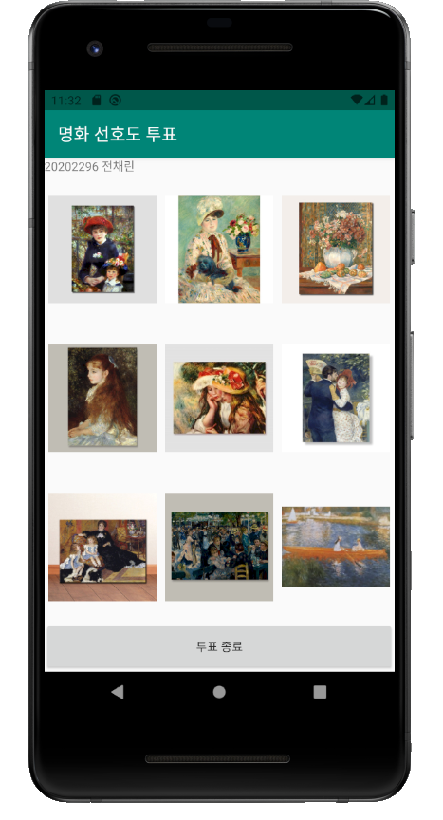

2) 영화 투표 화면

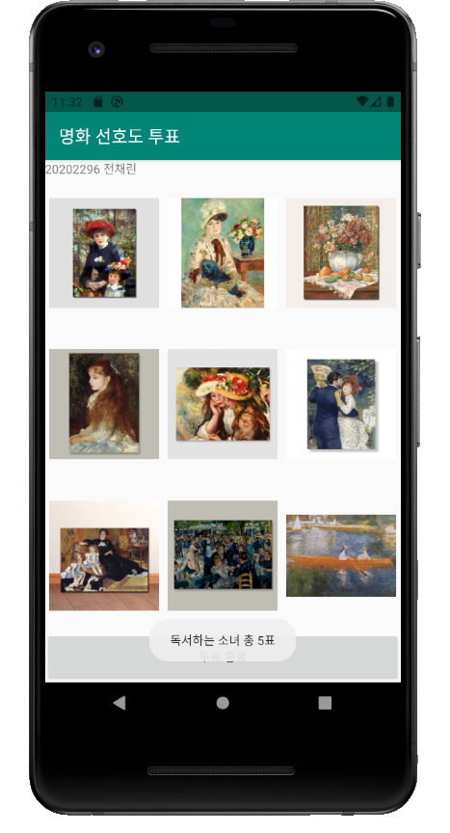

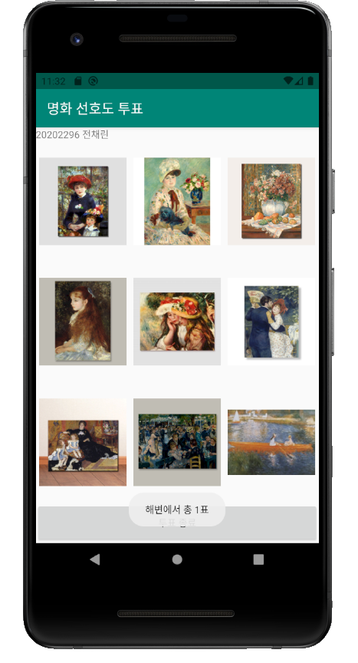

3) 투표 결과 화면

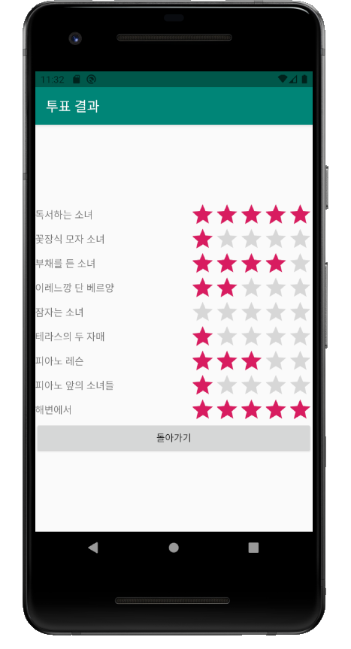

직접풀어보기 10-2 명화 선호도 투표 앱 만들기

[소스코드]

result.xml

<?xml version="1.0" encoding="utf-8"?>  
<TableLayout xmlns:android="http://schemas.android.com/apk/res/android"  
 xmlns:app="http://schemas.android.com/apk/res-auto"  
 xmlns:tools="http://schemas.android.com/tools"  
 android:layout_width="match_parent"  
 android:layout_height="match_parent"  
 android:gravity="center_vertical"  
 android:stretchColumns="0"  
 tools:context=".ResultActivity">  
  
 /* 직접풀어보기10-10 result.xml */  
 <TableRow>  
 <TextView  
 android:id="@+id/textTop"  
 android:layout_gravity="center"  
 android:layout_span="2"  
 android:text="## 우승 그림 제목 : "  
 android:textSize="15dp" />  
 </TableRow>  
 <TableRow>  
 <ImageView  
 android:id="@+id/imageTop"  
 android:scaleType="fitCenter"  
 android:layout_width="150dp"  
 android:layout_height="150dp"  
 android:layout_margin="10dp"  
 android:layout_span="2"  
 android:text="## 우승 그림 제목 : "  
 android:src="@drawable/pic1" />  
 </TableRow>  
 <TableRow>  
 <TextView  
 android:id="@+id/tv1"  
 android:layout_gravity="center_vertical"  
 android:text="그림1"  
 android:textSize="15dp" />  
 <RatingBar  
 android:id="@+id/rbar1"  
 style="?android:attr/ratingBarStyleIndicator"  
 android:layout_gravity="right" />  
 </TableRow>  
 <TableRow>  
 <TextView  
 android:id="@+id/tv2"  
 android:layout_gravity="center_vertical"  
 android:text="그림2"  
 android:textSize="15dp" />  
 <RatingBar  
 android:id="@+id/rbar2"  
 style="?android:attr/ratingBarStyleIndicator"  
 android:layout_gravity="right" />  
 </TableRow>  
 <TableRow>  
 <TextView  
 android:id="@+id/tv3"  
 android:layout_gravity="center_vertical"  
 android:text="그림3"  
 android:textSize="15dp" />  
 <RatingBar  
 android:id="@+id/rbar3"  
 style="?android:attr/ratingBarStyleIndicator"  
 android:layout_gravity="right" />  
 </TableRow>  
 <TableRow>  
 <TextView  
 android:id="@+id/tv4"  
 android:layout_gravity="center_vertical"  
 android:text="그림4"  
 android:textSize="15dp" />  
 <RatingBar  
 android:id="@+id/rbar4"  
 style="?android:attr/ratingBarStyleIndicator"  
 android:layout_gravity="right" />  
 </TableRow>  
 <TableRow>  
 <TextView  
 android:id="@+id/tv5"  
 android:layout_gravity="center_vertical"  
 android:text="그림5"  
 android:textSize="15dp" />  
 <RatingBar  
 android:id="@+id/rbar5"  
 style="?android:attr/ratingBarStyleIndicator"  
 android:layout_gravity="right" />  
 </TableRow>  
 <TableRow>  
 <TextView  
 android:id="@+id/tv6"  
 android:layout_gravity="center_vertical"  
 android:text="그림6"  
 android:textSize="15dp" />  
 <RatingBar  
 android:id="@+id/rbar6"  
 style="?android:attr/ratingBarStyleIndicator"  
 android:layout_gravity="right" />  
 </TableRow>  
 <TableRow>  
 <TextView  
 android:id="@+id/tv7"  
 android:layout_gravity="center_vertical"  
 android:text="그림7"  
 android:textSize="15dp" />  
 <RatingBar  
 android:id="@+id/rbar7"  
 style="?android:attr/ratingBarStyleIndicator"  
 android:layout_gravity="right" />  
 </TableRow>  
 <TableRow>  
 <TextView  
 android:id="@+id/tv8"  
 android:layout_gravity="center_vertical"  
 android:text="그림8"  
 android:textSize="15dp" />  
 <RatingBar  
 android:id="@+id/rbar8"  
 style="?android:attr/ratingBarStyleIndicator"  
 android:layout_gravity="right" />  
 </TableRow>  
 <TableRow>  
 <TextView  
 android:id="@+id/tv9"  
 android:layout_gravity="center_vertical"  
 android:text="그림9"  
 android:textSize="15dp" />  
 <RatingBar  
 android:id="@+id/rbar9"  
 style="?android:attr/ratingBarStyleIndicator"  
 android:layout_gravity="right" />  
 </TableRow>  
 <TableRow>  
 <Button  
 android:id="@+id/btnReturn"  
 android:layout_span="2"  
 android:text="돌아가기" />  
 </TableRow>  
</TableLayout>

ResultActivity.kt

package aca.hankook.practice10_2  
  
import androidx.appcompat.app.AppCompatActivity  
import android.os.Bundle  
import kotlinx.android.synthetic.main.result.*  
  
class ResultActivity : AppCompatActivity() {  
  
 override fun onCreate(savedInstanceState: Bundle?) {  
 super.onCreate(savedInstanceState)  
 setContentView(R.layout.*result*)  
  
 /* 예제10-14 ResultActivity.kt 코드 1 */  
 *title* = "투표 결과"  
  
 var intent1 = this.getIntent()  
 var voteResult = intent1.getIntArrayExtra("VoteCount")  
 var imageName = intent1.getStringArrayExtra("ImageName")  
  
 /* 예제10-15 ResultActivity.kt 코드 2 */  
 var tvArr = *arrayOf*(tv1, tv2, tv3, tv4, tv5, tv6, tv7, tv8, tv9)  
 var rbarArr = *arrayOf*(rbar1, rbar2, rbar3, rbar4, rbar5, rbar6, rbar7, rbar8, rbar9)  
  
 var max = 0  
 var imageFileArr = *arrayOf*(R.drawable.*pic1*, R.drawable.*pic2*, R.drawable.*pic3*, R.drawable.*pic4*, R.drawable.*pic5*, R.drawable.*pic6*, R.drawable.*pic7*, R.drawable.*pic8*, R.drawable.*pic9*)  
  
 for(i in voteResult!!.*indices*) {  
 if(voteResult[max] < voteResult[i])  
 max = i  
 }  
 textTop.*text* = imageName!![max]  
 imageTop.setImageResource(imageFileArr[max])  
  
 for(i in voteResult!!.*indices*) {  
 tvArr[i].setText(imageName!![i])  
 rbarArr[i].*rating* = voteResult[i].toFloat()  
 }  
  
 btnReturn.setOnClickListener **{** this.finish()  
 **}** }  
}

[실행결과]

1) 초기화면



2) 영화 투표 화면

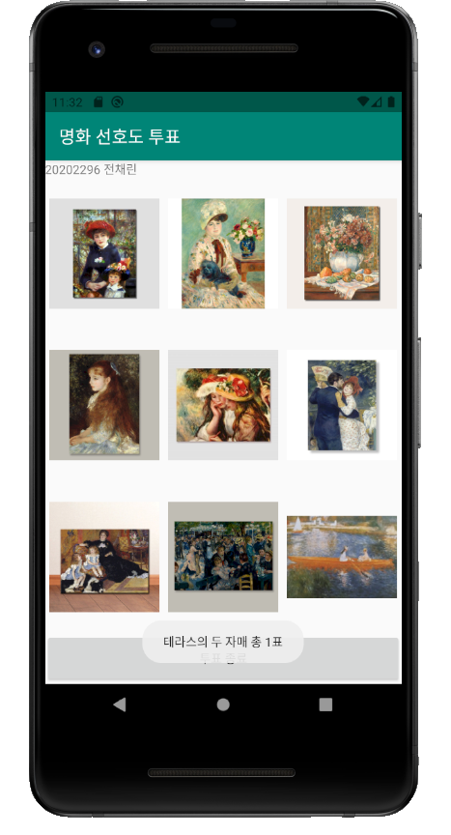

3) 투표 결과 화면

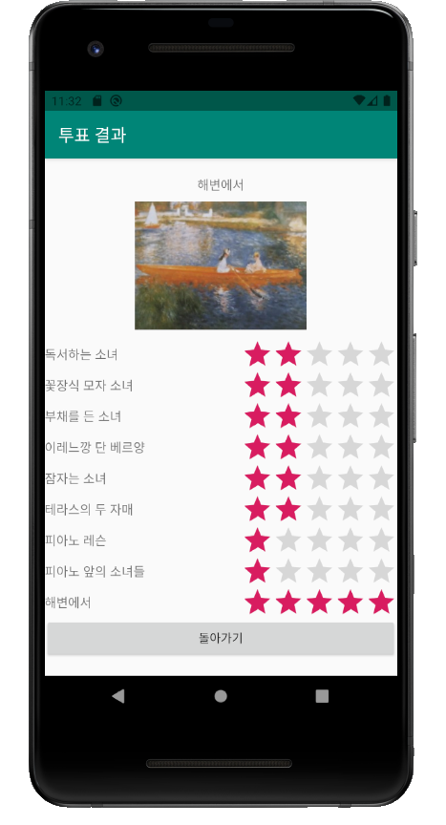

실습 10-2 명화 선호도 투표 앱 만들기

[소스코드]

activity_main.xml

<?xml version="1.0" encoding="utf-8"?>  
<LinearLayout xmlns:android="http://schemas.android.com/apk/res/android"  
 xmlns:app="http://schemas.android.com/apk/res-auto"  
 xmlns:tools="http://schemas.android.com/tools"  
 android:layout_width="match_parent"  
 android:layout_height="match_parent"  
 android:orientation="vertical"  
 tools:context=".MainActivity">  
  
 /* 02 암시적 인텐트  
 예제10-20 암시적 인텐트의 XML 파일 */  
  
 <TextView  
 android:layout_width="match_parent"  
 android:layout_height="wrap_content"  
 android:text="20202296 전채린" />  
 <Button  
 android:layout_width="match_parent"  
 android:layout_height="wrap_content"  
 android:id="@+id/btnDial"  
 android:text="전화 걸기" />  
 <Button  
 android:layout_width="match_parent"  
 android:layout_height="wrap_content"  
 android:id="@+id/btnWeb"  
 android:text="홈 페이지 열기" />  
 <Button  
 android:layout_width="match_parent"  
 android:layout_height="wrap_content"  
 android:id="@+id/btnGoogle"  
 android:text="구글 맵 열기" />  
 <Button  
 android:layout_width="match_parent"  
 android:layout_height="wrap_content"  
 android:id="@+id/btnSearch"  
 android:text="구글 검색하기" />  
 <Button  
 android:layout_width="match_parent"  
 android:layout_height="wrap_content"  
 android:id="@+id/btnSms"  
 android:text="문자 보내기" />  
 <Button  
 android:layout_width="match_parent"  
 android:layout_height="wrap_content"  
 android:id="@+id/btnPhoto"  
 android:text="사진 찍기" />  
</LinearLayout>

MainActivity.kt

package aca.hankook.ex10_20  
  
import android.app.SearchManager  
import android.content.Intent  
import android.net.Uri  
import androidx.appcompat.app.AppCompatActivity  
import android.os.Bundle  
import android.provider.MediaStore  
import kotlinx.android.synthetic.main.activity_main.*  
  
class MainActivity : AppCompatActivity() {  
  
 override fun onCreate(savedInstanceState: Bundle?) {  
 super.onCreate(savedInstanceState)  
 setContentView(R.layout.*activity_main*)  
  
 /* 02 암시적 인텐트  
 예제10-21 암시적 인텐트의 Kotlin 코드 */  
 *title* = "암시적 인텐트 예제"  
  
 btnDial.setOnClickListener **{** var uri = Uri.parse("tel:010-4604-5578")  
 var intent1 = Intent(Intent.*ACTION_DIAL*, uri)  
 startActivity(intent1)  
 **}** btnWeb.setOnClickListener **{** var uri = Uri.parse("http://m.naver.com")  
 var intent1 = Intent(Intent.*ACTION_VIEW*, uri)  
 startActivity(intent1)  
 **}** btnGoogle.setOnClickListener **{** var uri = Uri.parse("geo:0,0?q=동양미래대학교")  
 var intent1 = Intent(Intent.*ACTION_VIEW*, uri)  
 startActivity(intent1)  
 **}** btnSearch.setOnClickListener **{** var intent1 = Intent(Intent.*ACTION_WEB_SEARCH*)  
 intent1.putExtra(SearchManager.*QUERY*, "안드로이드")  
 startActivity(intent1)  
 **}** btnSms.setOnClickListener **{** var intent1 = Intent(Intent.*ACTION_SENDTO*)  
 intent1.putExtra("sms_body", "안녕하세요?")  
 intent1.*data* = Uri.parse("smsto:" + Uri.encode("010-4604-5578"))  
 startActivity(intent1)  
 **}** btnPhoto.setOnClickListener **{** var intent1 = Intent(MediaStore.*ACTION_IMAGE_CAPTURE*)  
 startActivity(intent1)  
 **}** }  
}

AndroidManifest.xml

<?xml version="1.0" encoding="utf-8"?>  
<manifest xmlns:android="http://schemas.android.com/apk/res/android"  
 package="aca.hankook.ex10_20">  
  
 <uses-permission android:name="android.permission.CALL_PHONE" />  
 <uses-permission android:name="android.permission.ACCESS_COARSE_LOCATION" />  
 <uses-permission android:name="android.permission.ACCESS_FINE_LOCATION" />  
  
 <application  
 android:allowBackup="true"  
 android:icon="@mipmap/ic_launcher"  
 android:label="@string/app_name"  
 android:roundIcon="@mipmap/ic_launcher_round"  
 android:supportsRtl="true"  
 android:theme="@style/AppTheme">  
 <activity android:name=".MainActivity">  
 <intent-filter>  
 <action android:name="android.intent.action.MAIN" />  
  
 <category android:name="android.intent.category.LAUNCHER" />  
 </intent-filter>  
 </activity>  
 </application>  
  
</manifest>

[실행결과]

1) 초기화면

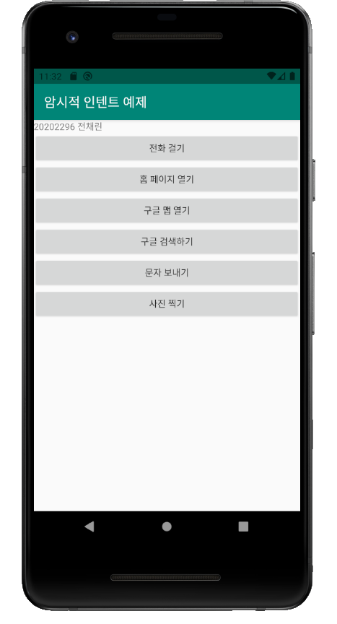

2) 전화 걸기 화면

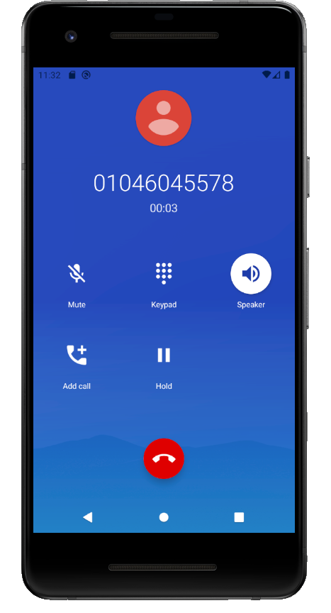

3) 홈 페이지 열기 화면

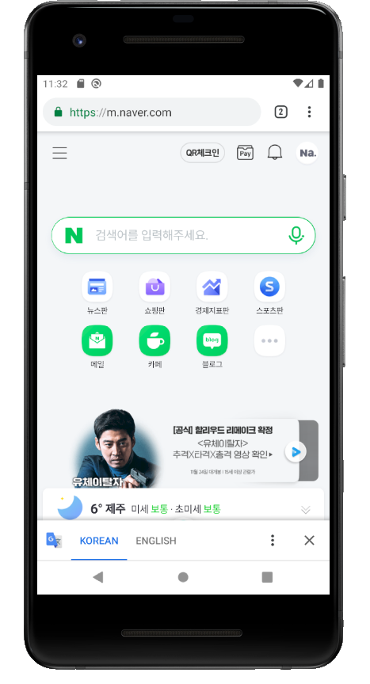

4) 구글 맵 열기 화면

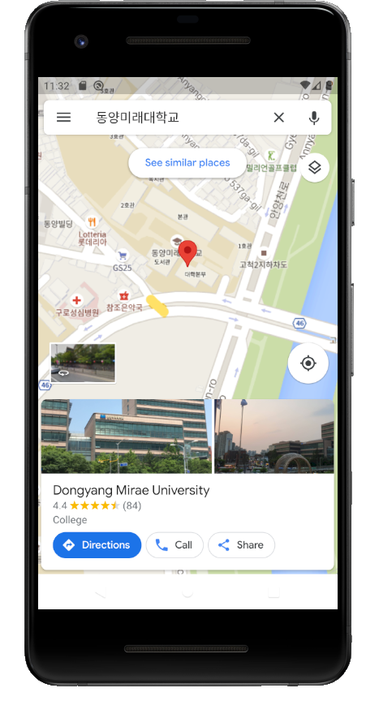

5) 구글 검색하기 화면

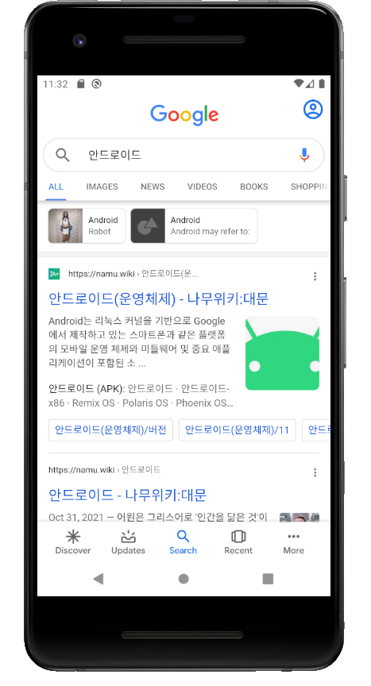

6) 문자 보내기 화면

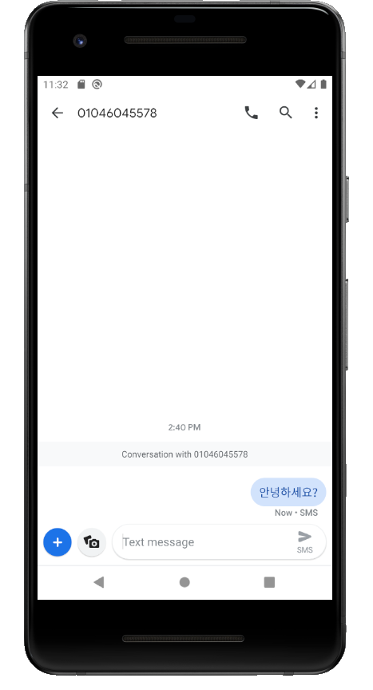

7) 사진 찍기 화면

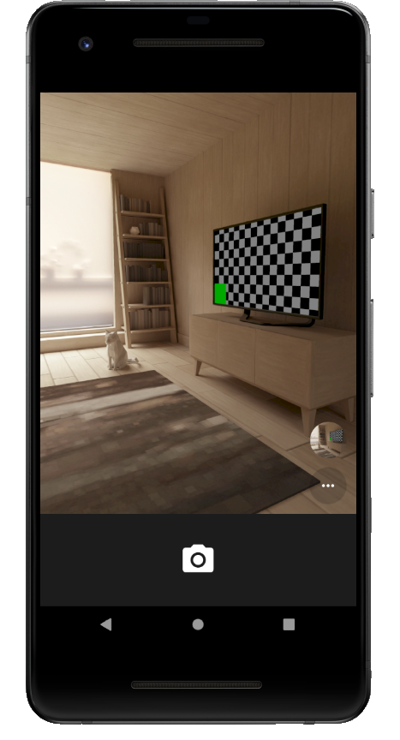

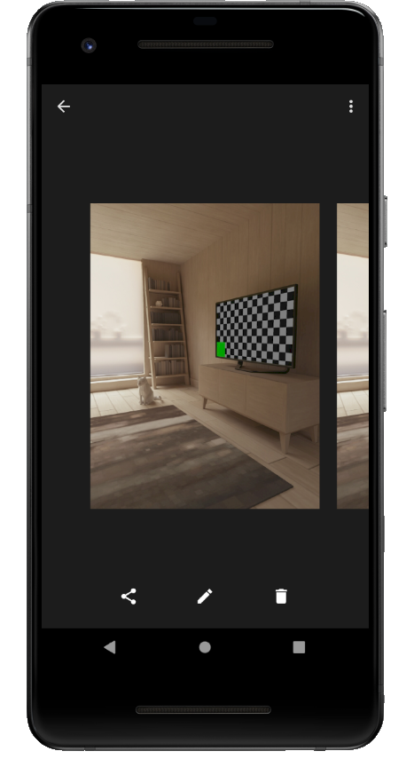

실습 10-3 로그캣을 이용하여 액티비티 생명주기 확인하기

[소스코드]

activity_main.xml

<?xml version="1.0" encoding="utf-8"?>  
<LinearLayout xmlns:android="http://schemas.android.com/apk/res/android"  
 xmlns:app="http://schemas.android.com/apk/res-auto"  
 xmlns:tools="http://schemas.android.com/tools"  
 android:layout_width="match_parent"  
 android:layout_height="match_parent"  
 android:orientation="vertical"  
 tools:context=".MainActivity">  
  
 /* 03 액티비티의 생명주기  
 실습10-3 로그캣을 이용하여 액티비티 생명주기 확인하기 */  
 /* 정상적인 상태의 액티비티 생명주기를 알아봄  
 로그캣(LogCat)을 활용하여 [그림 10-13]의 메소드가 실행되는 순서를 확인 */  
 /* 예제10-22 activity_main.xml */  
  
 <TextView  
 android:layout_width="match_parent"  
 android:layout_height="wrap_content"  
 android:text="20202296 전채린" />  
 <Button  
 android:layout_width="match_parent"  
 android:layout_height="wrap_content"  
 android:id="@+id/btnDial"  
 android:text="전화 걸기" />  
 <Button  
 android:layout_width="match_parent"  
 android:layout_height="wrap_content"  
 android:id="@+id/btnFinish"  
 android:text="끝내기" />  
</LinearLayout>

MainActivity.kt

package aca.hankook.project10_3  
  
import android.content.Intent  
import android.net.Uri  
import androidx.appcompat.app.AppCompatActivity  
import android.os.Bundle  
import kotlinx.android.synthetic.main.activity_main.*  
  
class MainActivity : AppCompatActivity() {  
  
 override fun onCreate(savedInstanceState: Bundle?) {  
 super.onCreate(savedInstanceState)  
 setContentView(R.layout.*activity_main*)  
  
 /* 예제10-23 Kotlin 코드 1 */  
 *title* = "액티비티 테스트 예제"  
 android.util.Log.i("액티비티 테스트", "onCreate()")  
  
 btnDial.setOnClickListener **{** var uri = Uri.parse("tel:010-4604-5578")  
 var intent1 = Intent(Intent.*ACTION_DIAL*, uri)  
 startActivity(intent1)  
 **}** btnFinish.setOnClickListener **{** finish()  
 **}** }  
  
 override fun onDestroy() {  
 super.onDestroy()  
 android.util.Log.i("액티비티 테스트", "onDestroy()")  
 }  
  
 override fun onPause() {  
 super.onPause()  
 android.util.Log.i("액티비티 테스트", "onPause()")  
 }  
  
 override fun onRestart() {  
 super.onRestart()  
 android.util.Log.i("액티비티 테스트", "onRestart()")  
 }  
  
 override fun onResume() {  
 super.onResume()  
 android.util.Log.i("액티비티 테스트", "onResume()")  
 }  
  
 override fun onStart() {  
 super.onStart()  
 android.util.Log.i("액티비티 테스트", "onStart()")  
 }  
  
 override fun onStop() {  
 super.onStop()  
 android.util.Log.i("액티비티 테스트", "onStop()")  
 }  
}

AndroidManifest.xml

<?xml version="1.0" encoding="utf-8"?>  
<manifest xmlns:android="http://schemas.android.com/apk/res/android"  
 package="aca.hankook.project10_3">  
  
 <uses-permission android:name="android.permission.CALL_PHONE" />  
 <uses-permission android:name="android.permission.ACCESS_COARSE_LOCATION" />  
 <uses-permission android:name="android.permission.ACCESS_FINE_LOCATION" />  
   
 <application  
 android:allowBackup="true"  
 android:icon="@mipmap/ic_launcher"  
 android:label="@string/app_name"  
 android:roundIcon="@mipmap/ic_launcher_round"  
 android:supportsRtl="true"  
 android:theme="@style/AppTheme">  
 <activity android:name=".MainActivity">  
 <intent-filter>  
 <action android:name="android.intent.action.MAIN" />  
  
 <category android:name="android.intent.category.LAUNCHER" />  
 </intent-filter>  
 </activity>  
 </application>  
  
</manifest>

[실행결과]

1) 초기화면

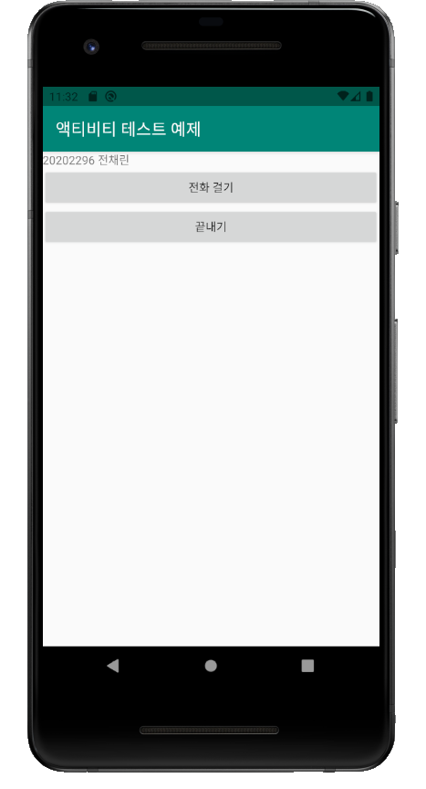

2) 로그캣 결과 화면

